Stephen Re Activity_13_5_cdc_cassandra

1

2 and 3

4

5a

5b

5c

6a and b

6c, d and e

7

8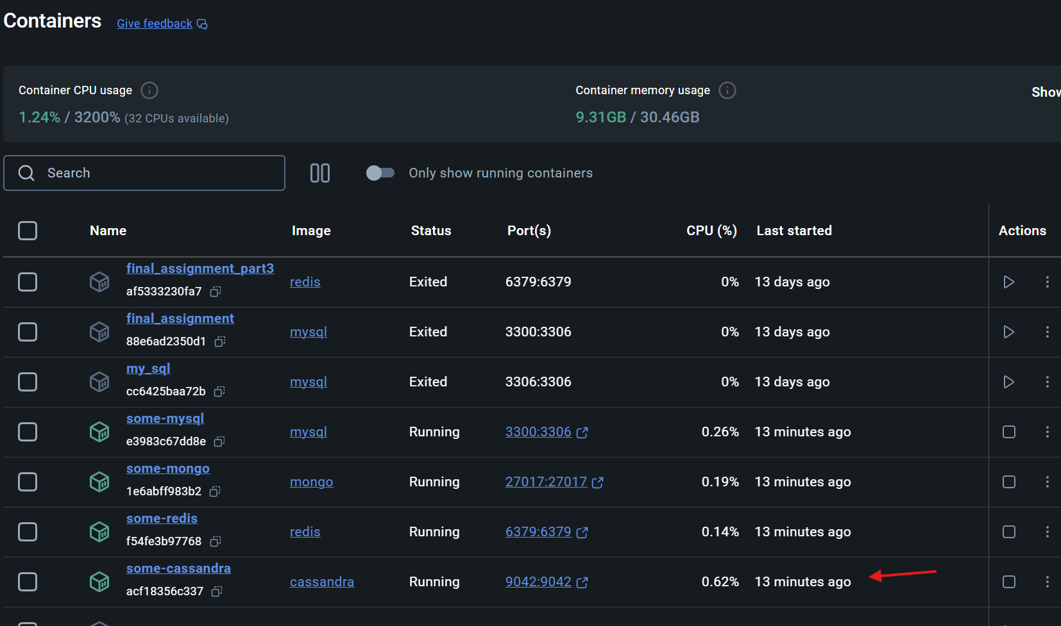

9 no errors

10

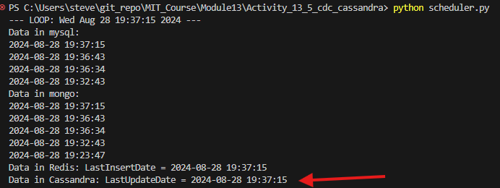

11

12

